Tommi Seedorf
ts1325@txstate.edu
580-541-5886

Tommi Seedorf
ts1325@txstate.edu
580-541-5886

Tommi Seedorf
ts1325@txstate.edu
580-541-5886

Tommi Seedorf
ts1325@txstate.edu
580-541-5886

Tommi Seedorf
ts1325@txstate.edu
580-541-5886

Tommi Seedorf
ts1325@txstate.edu
580-541-5886

Tommi Seedorf
ts1325@txstate.edu
580-541-5886

Tommi Seedorf
ts1325@txstate.edu
580-541-5886

Tommi Seedorf
ts1325@txstate.edu
580-541-5886

Tommi Seedorf
ts1325@txstate.edu
580-541-5886

Tommi Seedorf
ts1325@txstate.edu
580-541-5886

Tommi Seedorf
ts1325@txstate.edu
580-541-5886

Tommi Seedorf
ts1325@txstate.edu
580-541-5886

Do you have tight hamstrings?

We are looking for physically active
persons between the ages of 18-25
who have tight hamstring muscles and
have not had an injury to the lower
extremity in the past year. Your
participation will involve three visits
to the lab that will take no more
than 10 minutes each time.

Please contact Tommi Seedorf
for more details.

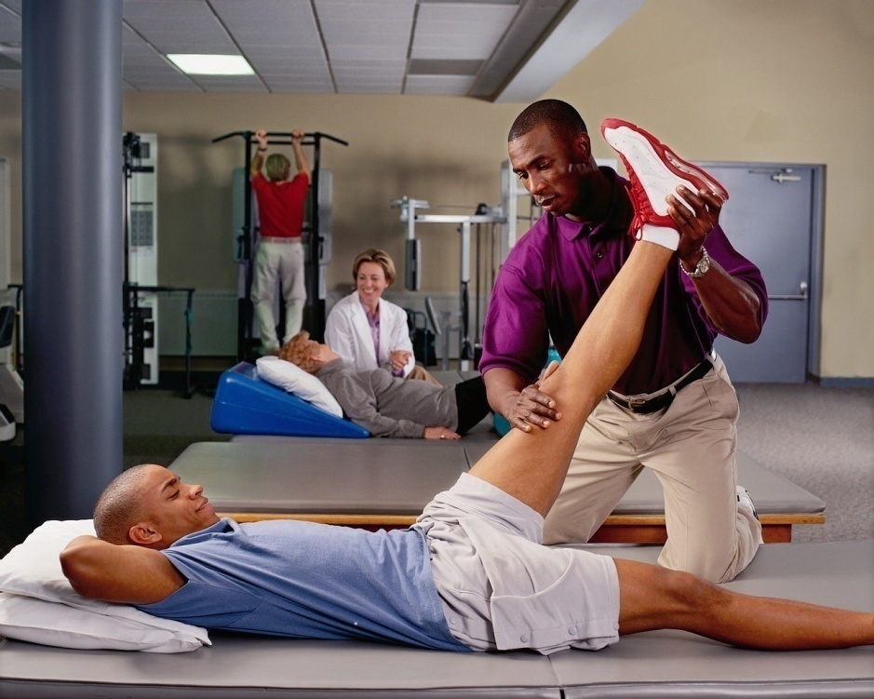

Contact Person: Tommi Seedorf
E-mail: ts1325@txstate.edu
Phone: 580-541-5886
Jowers Athletic Training Lab D108
Tommi Seedorf
ts1325@txstate.edu
580-541-5886

Tommi Seedorf
ts1325@txstate.edu
580-541-5886

Tommi Seedorf
ts1325@txstate.edu
580-541-5886

Tommi Seedorf
ts1325@txstate.edu
580-541-5886

Tommi Seedorf
ts1325@txstate.edu
580-541-5886

Tommi Seedorf
ts1325@txstate.edu
580-541-5886

Tommi Seedorf
ts1325@txstate.edu
580-541-5886

Tommi Seedorf
ts1325@txstate.edu
580-541-5886

